|  |  |
| --- | --- |
| **Biology, Castle View High School**  **Dr. Mayberry** |  |

**Study Guide: Nucleic Acids**

**Vocabulary**

1. Ribonucleic Acid (RNA)
2. Deoxyribonucleic Acid (DNA)
3. Transcription
4. Translation
5. Nucleotide
   1. Ribose
   2. Phosphate Group
   3. Nitrogenous Base
6. Adenine
7. Guanine
8. Cytosine
9. Uracil
10. Thymine
11. Deoxyribose
12. Complementarity
13. Antiparallel
14. Double Helix
15. ATP
16. Phosphorylation

**Conceptual Questions**:

1. Describe the relationship between DNA, RNA, and Proteins.

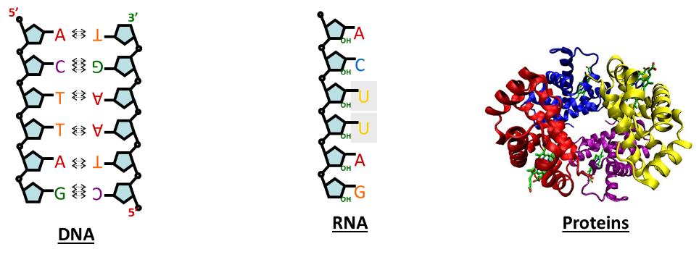

1. Draw a simplified monomer for RNA (ribonucleotide). What are its parts? Which part of the monomer is variable, and how does it vary?
2. Draw two RNA monomers (ribonucleotides) bound together in a chain. What type of reaction accomplishes this; describe what happens during this reaction.
3. Why is it significant that RNA remains single stranded, and that the sequence of ribonucleotides can cause it to fold into a precise shape?

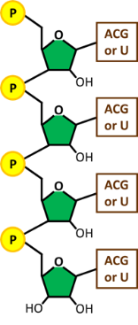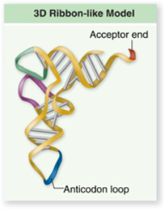

1. Draw a simplified monomer for DNA (deoxyribonucleotide). What are its parts. Which part of the monomer is variable, and how does it vary?
2. Beginning with ribonucleotides, describe the sequence of events that lead to the formation of the familiar DNA double helix.
3. Identify the ways that DNA is different than RNA.
4. Draw a simplified ATP molecule? Is it more like DNA or RNA (why)? How does it differ?
5. Describe how energy is stored in ATP, and how ATP can be used to fuel endergonic reactions.